Grantsmanship Seminar Series

**How to write a competitive proposal:**

**UAMS researchers sharing their experience on NIH grants**

The Division of Research and Innovation Seminar Series is designed to provide continuous education and training for UAMS investigators. The series will focus on topics that enhance investigators’ competitiveness for extramural funding and improve collaborations.

Topic 1: Writing a Successful DoD Grant Application – How is it different from an NIH application?

**Shuk-Mei Ho, PhD**

Vice Chancellor for Research & Innovation

Thursday, February 23, 2023; Virtual: 12-1 pm

Topic 2: Tips and Tricks for Productive Scholarly Writing

**Amy M. Franks, PharmD**

Professor and Chair

Department of Pharmacy Practice

Thursday, April 20, 2023; Virtual: 12-1 pm

Topic 3: Managing Multiple Projects

**Hari Eswaran, PhD**

Professor

Department of Obstetrics & Gynecology

Department of Biomedical Informatics

College of Medicine

Thursday, May 18, 2023; Virtual: 12-1 pm

Topic 4: Mentoring as a Key Component to Research Productivity

**Clint Kilts, PhD**

Professor and Wilbur Mills Chair in Alcohol and Drug Abuse Prevention

Director, UAMS NIDA T32 Training Program

Director, UAMS Brain Imaging Research Center

Department of Psychiatry

College of Medicine

Associate Director for Research

Psychiatric Research Institute

Thursday, June 15, 2023; Virtual: 12-1 pm

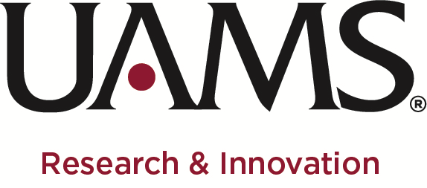

For comments on the seminar series or topic ideas

please email: Dr. Ho ([shukmeiho@uams.edu](mailto:shukmeiho@uams.edu))

or Elasri ([MOElasri@uams.edu](mailto:MOElasri@uams.edu))